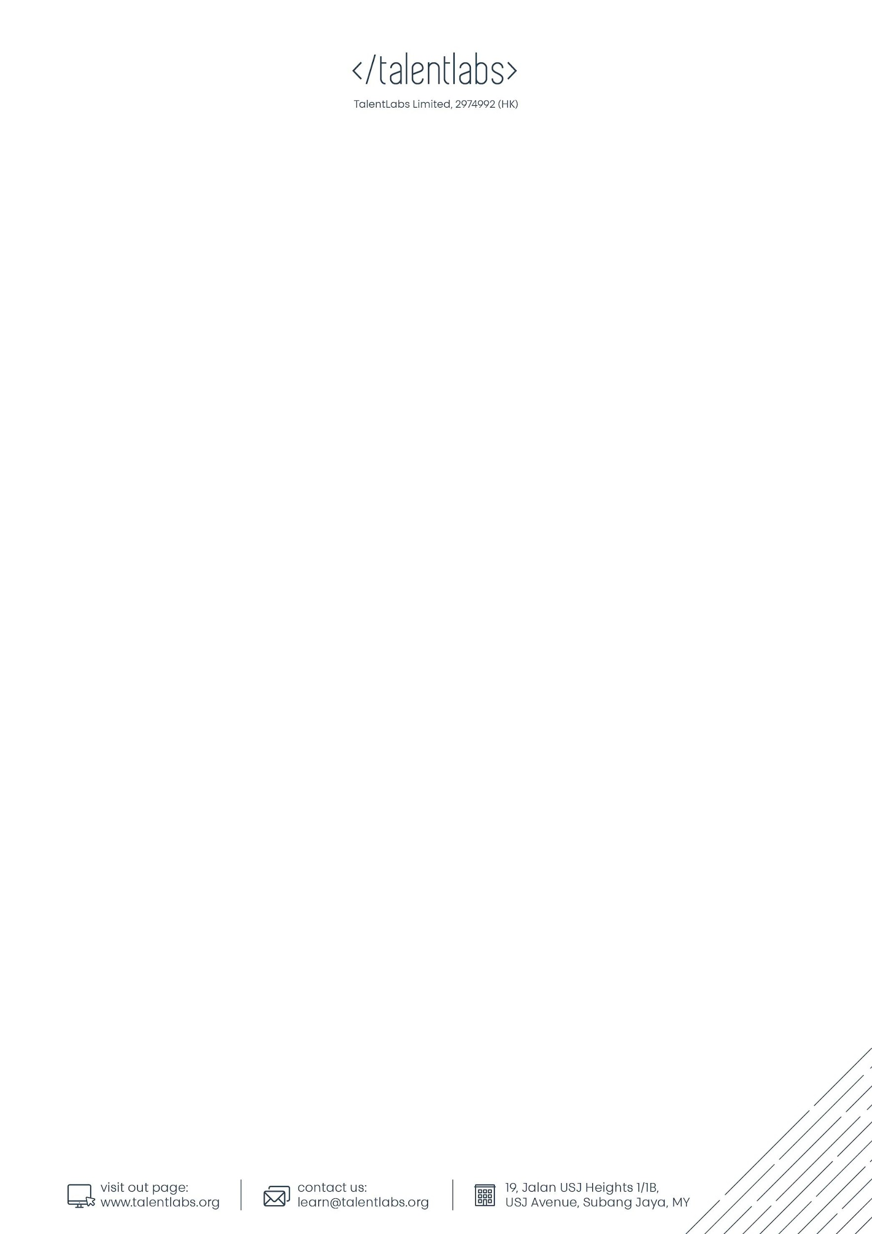Lab 2 Strings Manipulation Exercises

## Instructions

1. You can edit this file online (No copy is needed)
2. For each of the answers, please fill in your answers in the designated space
3. For submission, please submit it through Talentlabs learning platform.

## Part 1 Code Rewrite Exercise

In each of the sections below, please rewrite the code according to the instructions. The easiest steps for you to complete the exercises is to leverage the repl.it tool.

Steps:

1. Open <https://repl.it/languages/python3>
2. Copy the original code
3. Rewrite the code according to the requirements in repl.it tool
4. Test in repl.it until it works.
5. Copy the results back to this Answer Sheet.

### 2.1 Rewriting code by using Triple Quotes

The code below is using multiple new line escape characters (\n). Please rewrite it using triple quotes syntax to make it easier to read.

|  |
| --- |
| Original Code: |
| str1 = "Hello, I am Peter.\nI am now 10 years old.\nI like computers and machines."  print(str1) |
| Rewritten Code: |
|  |

### 

### 2.2 Rewriting Code by using Escape Characters

The code below is written using a mix of single quote and double quotes, so they can include quotes in the string. Please rewrite both strings using Escape Characters (\” or \’), so that each line would only have 1 type of quotes (either double quotes or single quotes).

|  |
| --- |
| Original Code: |
| str1 = 'Hello World! Do you really like "coding"?'  str2 = "Is this Peter's bag?"  print(str1)  print(str2) |
| Rewritten Code: |
|  |

### 

### 2.3 Rewriting Code by \ character

The code below is a very long string so it is very hard to read. Please rewrite using \ character to break it down into multiple lines.

|  |
| --- |
| Original Code: |
| str1 = "Hello. This is a very long string. Please break it into multiple lines so it is easier to read"  print(str1) |
| Rewritten Code: |
|  |

### 

### 2.4 Rewriting Code by using .format() function

The code below has 2 problems: (1) too many “+” operators makes the code very hard to read; (2) the string is too long and very hard to read if we put it into one line.

Please rewrite the code using .format() function and the \ symbol

|  |
| --- |
| Original Code: |
| today = "2021-09-12"  day_of_week = "Wednesday"  weather_today = "Sunny"  temperature = 28  print("Today's date is " + today + ", " + day_of_week + ". Today's weather is " + weather_today + ". Today's temperature is " + str(temperature) + " degree celsius.") |
| Rewritten Code: |
|  |

## Part 3 Submission

### Zip the whole file and upload the file to Talentlabs learning platform.